Final Report to the University Senate
FY2017 Ad Hoc Committee on Diversity, Equity and Inclusion

Chair: Ruben Flores
Committee members
Members:
Pam Fine
Cecile Accilien
David Day
Michael Chavez
Stephonn Alcorn
Danny Summers
Trinity Carpenter
Sneha Verma
Charges: Discussed by FacEx: November 29, 2016
Approved by University Senate: December 1, 2016
Standing Charges:

On November 3, 2016, the Multicultural Student Government presented a resolution to the University Senate calling for an exploratory committee to study the feasibility under the University Code of the formation of a permanent MSG government (autonomous from, but operating alongside, the Student Senate), and to study the amendments to the University Code that would be required to allow a permanent MSG legislative delegation to be granted seats on the University Senate in the event that such an MSG government were created. [See Pages 19-24 for a copy of the MSG resolution.] The University Senate tabled the MSG resolution for further study on that same day.

At the next University Senate meeting on December 1, 2016, the Senate voted in favor of MSG’s request to pull the original resolution in favor of a new resolution forming an ad hoc committee on diversity, equity, and inclusion. [See the new resolution at Pages 17-18.] The new resolution passed the University Senate, and the “University Senate Ad Hoc Committee on Diversity, Equity, and Inclusion within University Governance” was formed.

FEBRUARY 16: INITIAL MEETING
The nine members of the University Senate Ad Hoc Committee on Diversity, Equity, and Inclusion within University Governance (hereafter called the DEI) met on February 16, February 23, March 9, and April 13. Faculty members of the committee also attended meetings of the Student Senate, its committees, and its discussion sessions with MSG between February and April 2017.
On February 16, associate professor Shannon Portillo presented by invitation from the committee the findings of the chancellor’s 2015-2016 Advisory Group on Diversity, Equity, and Inclusion, whose report had provided the opening language of the committee charge that had created the DEI. That language is replicated below. [Note: The Chancellor’s Advisory Group should NOT to be confused with the DEI. The Advisory Group was separately commissioned by the chancellor in 2015 and was co-chaired by Professor Portillo.]
“The purpose for this committee will be to implement the April 2016 recommendation of the Provost’s Diversity, Equity, and Inclusion Advisory Group that the University Senate “take special action to review: the structure of student representation in University governance to ensure equitable representation between the MSG [Multicultural Student Government] and the current Student Senate; Student Senate elections processes to determine if Student Senate elections might be best administered by a University Senate committee comprised of students, staff, and faculty; how to disrupt concentrations of power within the Student Senate in order to ensure that the Student Senate is inclusive, representative, and allows for broad participation from the student body; and whether coalitions should be abolished in the Student Senate elections process, thus requiring students running for Senator seats to campaign directly with the constituent students they seek to represent” (p. 21, Advisory Group Report).”
A consensus agreement emerged after Portillo’s presentation that the committee needed to establish short-term and long-term goals that were in line with the language of the resolution that created the DEI, and to establish a list of priorities for addressing those goals. The resolution’s mandate (1) to review the structure of student representation in governance, (2) to consider the abolition of the coalition system that governs Student Senate elections, and (3) to review the elections process of the Student Senate seemed like relatively short-term goals. The resolution’s larger charge to “disrupt concentrations of power with the Student Senate,” however, seemed a long-term goal. The DEI also recognized the short calendar it was operating with, given that an April 15 deadline had been set for reporting to the University Senate.
Given the timing of the committee’s work and need to establish working priorities, the members of the DEI were asked to formulate a list of recommendations for potential action to be considered at the committee’s next meeting on February 23. The student representatives (Alcorn, Summers, Carpenter, Verma) were asked to consider recommendations for changes to the student representation system, in keeping with the committee’s original charge from the University Senate.

FEBRUARY 23 MEETING: STUDENT SENATE AND MSG LIST OF PRIORITIES
On February 21, the student representatives of the DEI met together in advance of the committee’s February 23 meeting and produced a schedule of priorities for changes to the student representation system. At a meeting they jointly convened, DEI student member and MSG representative Trinity Lawrence, DEI student member and Student Senate president Stephonn Alcorn, and DEI student member and Student Senate chief of staff Danny Summers (1) compiled a list of recommendations for reforming the Student Senate representation system, and (2) jointly agreed to present the list to the DEI for consideration at the February 23 DEI meeting. [That document, entitled “University Ad-Hoc Committee: Background & Context,” is included on Page 25.] Alcorn, Summers, and Carpenter identified nine suggestions for action by the DEI, as listed below.
  - Complete removal of the coalition process by referendum to the Student Body
  - Change how the Student Body President and the Student Body Vice President are elected to increase election based on merit and not solely on popularity
    - Student body speech
    - Interview component
  - Examine and make changes to the way the Student Body President and Student Body Vice President make university committee and board appointments to ensure representation by all campus groups
  - Equitable Representation in Campus Fee Review
  - Require senatorial candidates to participate in campus debates and forums with their respective divisions
  - Change the Freshmen Elections Process
  - Examine Student Senate voting and speaking rights procedure and access the feasibility of speaking rights for all students
  - Examine the Campus Fee Review allocation process and determine if there should be a window for open feedback from the Student Body (University Senate often sends amendments to full list serv, should Student Senate do this as well?)
  - Assess how freshmen students are introduced into Students and determine further ways freshmen, particularly minority freshmen, can be introduced to student senate in ways similar to white peers

At its February 23 meeting, the DEI discussed the list of recommendations compiled by the student representatives and by consent identified three items as the committee’s basis for proceeding forward. These three items included (1) fee review, (2) the elimination of the coalition system by means of a student referendum, and (3) changing the procedures by which the student body president and vice president make university and board appointments.

The DEI’s rationale for supporting the three items included two reasons. (1) First, Alcorn, Summers, and Carpenter reported to the committee that legislation targeting each was possible to enact in the Student Senate before the end of the academic year, potentially resulting in policy changes to the student representation system by the end of the academic year. Such immediate changes were deemed symbolically and substantively important. (2) Second, the three items had been arrived at jointly by members of the Student Senate and of MSG. Such unified action was considered worthy of support in view of the larger need to strengthen the relationship between MSG and the Student Senate.

LEGISLATIVE ACTIVITY IN THE STUDENT SENATE

Concurrent with the February 23 DEI meeting, Alcorn, Summers, and Carpenter had initiated a new round of legislation designed to increase multicultural representation within the Student Senate by amending the Student Senate Rules and Regulations (hereafter called SSRR). The new legislation represented the legislative analog of the action items they recommended to the DEI on February 23.

Some sense of the rationale for initiating the new legislation was indicated in an April 25 article published in The Daily Kansan. [The article is included in full at Pages 28-31.] There, Student Senate president Stephonn Alcorn and Student Senate vice-president Gabby Naylor indicated that the formation of the DEI by the University Senate had had the effect of generating momentum for new conversations about equitable representation within the Student Senate, despite the clear recognition that the matter of representation had been a concern of the Student Senate for at least one year prior to the formation of the DEI.
DAILY KANSAN: How do you feel being put under review [by the University Senate] affected your time in Student Senate?
Alcorn: It characterize us as Student Senate being put under review while we were already doing the work, which is fine. The work with MSG and the coalition referendum and the cultural competency trainings and different things to make Student Senate open and accessible, that come out of the [University Senate] review and that [DEI] committee. What happened was as we were discussing these things was think, “We don’t need to wait. We don’t need a committee report to tell us things that we can figure out now amongst ourselves.” If anything, it helped bring everyone to the table. We had the toughest conversations, but accomplished those things a whole lot sooner because we know we couldn’t just keep kicking it down the curb.
Naylor: It opened the door for a lot of conversations on the University Senate side … For the first time in the course of my year in University Senate, we were talking about how faculty and staff can help Student Senate and how we can kind of work on different projects. We were asking each other for advice and guidance and kind of understanding how each of our bodies work similarly and differently.
The result of the legislation written by Alcorn, Summers, and Carpenter was policy action at the March 15 and April 5 Student Senate meetings that amended the SSRR to increase representation for multicultural students in the Student Senate. Collectively, the new legislation was significantly broader than the three items that the DEI had identified for action at the February 23 DEI meeting.

The new legislation collectively enacted the following changes to the SSRR:

- The Student Senate passed a bill to offer a student referendum during the
academic year 2017-18 to consider whether the coalition system through which
student elections currently operate should be abolished. The referendum responds to the University Senate’s charge to the DEI that the committee undertake an analysis whether the coalition system should be abolished;

- The Student Senate amended the SSRR to mandate that MSG should be granted committee seats on the Student Senate committees that govern the dispersal of student fees. The new legislation responds to the University Senate’s charge to the DEI that the committee find ways ensure equitable representation for the MSG in the Student Senate;

- The Student Senate passed a series of bills mandating cultural competency training for officers of the Student Senate and candidates who run for Student Senate office. This series of bills responds to the University Senate’s charge to the DEI that the committee examine ways to broaden representation in the Student Senate;

- The Student Senate amended the SSRR to create a permanent seat for the Multicultural Student Government in the Student Senate. The new legislation responds to the University Senate’s charge to the DEI that the committee find ways ensure equitable representation for the MSG in the Student Senate;

- The Student Senate amended the SSRR to create a permanent seat for the MSG in the University Senate. The new legislation responds to the University Senate’s charge to the DEI that the committee examine ways ensure equitable representation for the MSG in the University Senate;

- The Student Senate ratified a bill that funded MSG as a unit of the Student Senate for the academic year 2017-2018;

- The Student Senate and MSG entered into a memorandum-of-agreement that defines the formal relationship of the two groups to one another. The MOA specifies that MSG will remain a part of the Student Senate and will not operate as an independent government.

CONSEQUENCES OF LEGISLATIVE ACTIVITY IN THE STUDENT SENATE

The amendments to the SSRR undertaken by the student members of the DEI represented significant movement in the direction of the University Senate’s charge to the DEI. [We note that the students undertook the amendments within their capacity as members of the Student Senate and not within their capacity as members of the DEI.] Tangible institutional steps were implemented in the direction of more equitable representation for MSG within the Student Senate and within the University Senate. To the extent that they amended the SSRR, these steps went beyond the DEI’s charge to review and propose changes to the USRR, SSRR, and FSRR regarding the relationship between the Student Senate and MSG. These steps also fit the DEI’s consensus at the February 16 DEI meeting that both short-term and long-term goals had to be pursued to adequately transform the representation system of the Student Senate. [See Pages 26-27 for a Daily Kansan article reporting on the successful legislation.]

It should be recognized that the successful legislation was the product of difficult negotiating sessions by the Student Senate and MSG both. Even as they had been tasked to sit on the DEI, Student Body President Stephonn Alcorn, Vice President Gabby Naylor, Chief of Staff Danny Summers, Senator Sophia Templin, and MSG President Trinity Carpenter conducted difficult and sometimes tense negotiating sessions in preparation for the legislative procedures that culminated in the policy changes to the SSRR. Those sessions included discussions in the permanent standing committees of the Student Senate, meetings between Student Senate leaders and MSG leaders, parliamentary debate within the full Senate, and important email correspondence. The successful legislation reflected a model of student negotiation between the Student Senate and MSG that can be replicated in subsequent years.

The legislation should not be considered a full solution to the question of equitable representation in the Student Senate nor a full response to University Senate resolution that created the DEI. The cautious quality of the successful legislation was noted by Student Senator Sophia Templin at the March 9 meeting of the DEI, who commented that the reforms were, “…duct tape on a pipe, rather than a whole new pipe.” [Templin had been asked by DEI chair Ruben Flores to report on the deliberations within the Student Senate that had produced the SSRR legislation.] Templin’s comment accurately describes the reading that should be given to the new legislation. While it represented a significant step in the direction of serious policy reform within the Student Senate, the legislation should be carefully examined in 2017-18 for its effects on the relationship between MSG and the Student Senate. The new legislation called for a coalition referendum to be ratified and held by the Student Senate, but that referendum must be successfully organized during the academic year 2017-2018 and may ultimately fail a student vote. The legislation granted one seat to MSG in the University Senate, but that allocation should be examined for its effects on broadening debate between faculty, staff, and students. The new requirements for cultural competency training for Student Senate candidates are important, but they will not transform student representation structures within the Student Senate by themselves.

Credit for the successful legislation must be given to MSG and the Student Senate. Credit must be given to MSG for its critiques of the Student Senate’s representation system - the results of which included the University Senate resolution that created the DEI - and for its negotiations with the Student Senate in pursuit of the successful legislation. The Student Senate must be recognized for negotiating in a spirit of compromise and for directing the successful legislation to its final conclusion since in an effort that was neither automatic nor easy.

For their part, the University Senate and the DEI must be recognized for their role in the successful legislation. The DEI helped foster a climate of discussion between MSG and the Student Senate, since, as Student Body President Stephonn Alcorn noted to The Daily Kansan on April 25, it “…helped bring everyone to the table.” In the words of Student Body Vice President Gabby Naylor to The Daily Kansan on April 25, the DEI also “…opened the door for a lot of conversations on the University Senate side.” The work of the DEI, Naylor added, was important to the extent that the University Senate and Student Senate “…were asking each other for advice and guidance and kind of understanding how each of our bodies work similarly and differently.” [See the Kansan article in full at Pages 28-31.] By attending the Student Senate committee meetings, parliamentary debates, and negotiating sessions, faculty members of the DEI made inroads in bridging a credibility gap between the Student Senate and the University Senate and helped create a climate of reciprocal respect not previously in place. (DEI committee members attended Student Senate committee meetings on March 8 and Student Senate parliamentary debates on March 15 and April 5. In addition, they met with Student Senate officers, MSG officers, and joint negotiating sessions during the last three legislative cycles.)

MARCH 9 AND APRIL 13 MEETINGS: DISCUSSIONS OF LEGISLATIVE ACTION IN THE STUDENT SENATE

Because the amendments to the SSRR represented a series of complicated actions within the Student Senate, the DEI committee devoted its March 9 and April 13 meetings to understanding the consequences of those actions for student representation and the extent to which the legislative changes fit the charge that the University Senate had given to the DEI.

The March 9 DEI committee meeting raised a number of important questions and comments for the student representatives. The discussions are summarized below.

In addition to the legislation that passed, a fee bill was proposed for the purpose of funding the MSG as a student organization. That bill did not need to pass the full Student Senate and receive the chancellor’s approval in order for MSG to be granted seats on the Student Senate and the University Senate. The latter could take place without the former. The fee bill funding MSG was important to consider separately insofar as Chancellor Gray Little would not make a recommendation for or against its approval until late May, after the academic year was over. Meanwhile, the provisions for seats in the Student Senate and University Senate could stand on their own.

Operating money from student fees earmarked for MSG through Student Senate legislation was allocated to the Office of Minority Affairs (OMA), but OMA would target that money only for the exclusive use of MSG.

The bills amending SSRR sought to incorporate MSG as a unit of the Student Senate rather than as a separate and independent body. One primary reason was to address concerns raised by the chancellor during academic year 2015-2016 that two separate student governments could not exist simultaneously under Kansas Board of Regents policy. A second was to foster a better working relationship between the Student Senate, MSG, and multicultural students more broadly.

The tension between MSG and the Student Senate is not primarily a question of appro-priating operating money to MSG. As indicated above, Both sides agree that the true source of friction is disagreement about whether MSG should properly operate as a separate and autonomous student government.

The discussions and negotiations between the Student Senate and MSG were conducted in a notable spirit of reconciliation. A sense of mutual engagement characterized the meetings between the two sides, even as they were still debating the ultimate political outcomes of their negotiations. Still, such a spirit of reconciliation is fragile and should not be taken to mean that MSG and the Student Senate agree in principle that MSG’s permanent place is as a unit of the Student Senate. Instead, it means that the short-term reconciliation that produced the successful legislation was a step in the direction of establishing long-term trust and planning between the two sides.

There is strong sentiment that eliminating the coalition system via a student referendum is a real possibility for transforming the Student Senate’s representation system. Some members of the DEI committee believe it may be more important than funding MSG on a year-to-year basis. MSG sees operating funds and recognition as an independent government as more important, despite its own view that the coalition system should also be transformed.

There remains strong and principled disagreement on whether MSG’s proper long-term relationship to the student body is as a unit of the Student Senate. Substantial more conversation on the matter will be important to conduct in subsequent academic years.

The April 13 discussions of the DEI are summarized below.

The DEI held a discussion about whether or not to carry its work forward into academic year 2017-18. A related consideration was whether the committee should be ad-hoc again in 2017-18 or turned into a standing committee given that there is no shortage of diversity matters currently facing the university, including faculty recruitment, student recruitment and retention, and the climate survey produced in 2017 by the Office of the Provost. The consensus was that the DEI should be extended into 2017-18, in the form of a standing committee of the University Senate. Members of the Student Senate were especially supportive of the DEI and believed it had created a climate for substantive negotiations with MSG.

The DEI expressed concern about maintaining continuity between the outgoing and incoming classes of Student Senate and MSG members. Both groups will have new officers who must be brought into the DEI deliberations.

Committee member David Day recommended that OMA be brought into the DEI deliberations in order for the University Senate to hear from a larger body of marginalized students across the university rather than MSG alone. Perhaps OMA should have a role in selecting members of the DEI.

The Student Senate in looking for strategies to increase participation in its deliberations from minority groups and others whose attendance and participation has not been regular. There is recognition within the Student Senate that its meetings have not always been hospitable to marginalized students.

SEPARATE STUDENT GOVERNMENTS?

The deliberations of the DEI and Spring 2017 amendments to the SSRR by the Student Senate have underscored that the question of representation in the Student Senate is a complicated and multidimensional one. Any consideration of potential changes to the current student representation system involves extended conversation and thought, including such possibilities as transforming the coalition system that governs student elections, increasing MSG representation within the Student Senate, and changing the composition of the Student Senate committees that control the dispersal of student fees. Related factors must be taken into account, including the allocation of Senate committee assignments and seats, the relationship of the University Senate to the Student Senate, and the relationship of the sorority and fraternity system to student elections.

Such conversations should include discussions of an independent MSG. Considering the possibility of a separate MSG, autonomous from the Student Senate and operating as a fourth body in the University Senate, was a part of the University Senate’s charge to the DEI. Meanwhile, amid the successful changes to the SSRR, MSG continues to advocate for the creation of a separate student government. The May 1 issue of the Daily Kansan, for example, reported that independence from the Student Senate will remain an important to MSG in 2017-18. [The article is included in full at Pages 32-33.]

The DEI committee believes that it would be detrimental to the university to create an MSG that is autonomous from the Student Senate. Follow-on claims for autonomy might potentially be made by other organizations with no clear basis on which to deny such separation. The possibility of an autonomous MSG raises questions of multiple student body elections and corresponding changes to the system that disperses student fees. The presence of two autonomous student senates would seem to convey the message that the members of the student body are unable to engage one another directly in the effort to transform the University of Kansas. It would seem to suggest that institutional change is not possible despite the fact that the Student Senate and MSG worked together successfully to amend the SSRR. It would suggest that the university has accommodated itself to an absence of political dialogue when the university’s ultimate value resides in the creation of such dialogue.

Yet the DEI is also well aware that the changes to the Student Senate achieved this spring do not permanently resolve the matter of broader representation within student governance for MSG and other minority students. The changes have been noteworthy, but they should be seen as only the initial steps in a longer-term effort to (1) modify the structures of representation at the University of Kansas in the direction of greater inclusivity; (2) broaden access and control over student fees that amount to $20 million dollars per year (more than $80 million over the course of a 4-year undergraduate career); and (3) broaden access to the Student Senate’s leadership positions. The Student Senate should not control student resources in perpetuity within a student representation system that systematically shuts our minority voices from systems of control and access. African-Americans have more recently assumed leadership roles with the Senate, but the representation system historically has been narrower than the breadth of the student body and remains systematically out of reach to many of KU’s undergraduate students.

Given the enormous importance of a strong student government at the University of Kansas, the University Senate should consider the costs and benefits of a separate government for MSG, and whether a separate MSG government is necessary in order to produce a broader and more diversified Student Senate. In part because there has been little substantive discussion about creating an independent MSG (IE, a separate student government independent of the Student Senate), the long-term benefits to the university of separation are not self-evident. The University Senate should not refrain from inquiring about independence, but separation must be discussed diligently, forthrightly, and with intense scrutiny. Otherwise, the university risks creating a stalemate among student groups rather than fostering a climate in which substantive dialogue can be produced, and risks foreclosing the chances for political change enacted by a student body that acts together in the name of the broad set of constituencies that the university represents.

An additional question should also be considered. To the extent that the outcomes of broadened representation must be enacted through university policy-making, the University Senate should give additional attention to the precise institutional mechanisms through which broadened representation is to be achieved. Change as a strategic goal is fundamental to consider. But enacting change tactically through the policy-making units of the university can be a lengthy process involving prolonged negotiations among contending parties. Such action requires planning and coordination to an extent not always mutually recognized by the interested constituencies. As one example, the Student Senate legislation that resulted in the successful amendments to the SSRR was a multi-tiered process that required diligent policy-making and discussion over prolonged windows of time. While the DEI was organizing for the March 9 meeting, the initial Student Senate bills had passed out of committee on March 8 and were enroute for consideration by the full Student Senate on March 15. This process did not lend itself easily to the meeting schedules of the University Senate and its committees and is itself a process that requires significant effort to understand. Such policy work is neither automatic nor guaranteed and requires heavy mutual engagement by all of the interested parties, including the University Senate.

That hard policy work has a better chance to be achieved if a strong relationship is allowed to develop between the Faculty and Student Senates. The University Senate exists as a means to enable discussions among the major constituencies of the university community, including faculty, staff, and students. Its voting structure includes the three constituencies, and the expectation is clear that University Senate meetings are for the purpose of enhancing communication among the three constituencies for the purpose of making policy recommendations to the university administration. But the historically weak relationship between the Faculty senate and the Student senate has exacerbated the challenges to university governance on the representation issue. The University Senate is largely unaware of the cycles and procedures through which the Student Senate operates. It has not had a strong relationship to the officers and committee chairs of the Student Senate. Meanwhile, few college administrators have wrestled with the question of marginalized student representation within the Student Senate on a systematic basis, for reasons that remain unclear. Such unfamiliarity impedes the work of collaboration and prevents consensus from developing on the fundamental question of equity and inclusion. Student leaders have voiced their desire to work more closely with the University Senate, but it will take time and effort to close their distant relationship to university governance that has produced misunderstandings and cynicism.

DEI RECOMMENDATIONS FOR 2017-18

The DEI recommends that the DEI committee of the University Senate be transformed from an ad-hoc committee to a permanent standing committee. Whether the original charge should be maintained or potentially modified to include broader campus diversity and inclusion concerns is a matter that should be raised and discussed.

The DEI should continue to facilitate the evolving relationship between the Student Senate and MSG. The amendments to the SSRR this spring were extraordinary results accomplished by the two groups. But the effects of the legislation should be scrutinized and discussed by the University Senate as a whole and the DEI as a committee, including the effects on the relationship between the two student organizations over the subsequent academic year.

The University Senate should strive to build a stronger working relationship to the Student Senate, perhaps through the mechanism of the University Senate Executive Committee. What is important is better familiarity with the operation of the Student Senate, including its legislative cycles and the operation of the SSRR.

The DEI was unable to take up detailed deliberations on the matters of the feasibility of an independent MSG, alternative models of student elections, or alternative models for the allocation of student seats within the Student Senate. This was largely a result of short time-frame allocated for the DEI to perform its deliberations in Spring 2017. We recommend a return to a consideration of each of these matters in 2017-18.

The DEI should review the memorandum-of-agreement signed between the MSG and the Student Senate as a result of the amendments to the SSRR that were accomplished in Spring 2017. The DEI should make itself aware of the language that defines the operating agreement between the MSG and the Student Senate.

APPENDICES

Ad hoc committee resolution enacted by majority vote of the University Senate on 1 December 2106:

************************
The University Senate Ad Hoc Committee on
Diversity, Equity, and Inclusion within University Governance
The purpose for this committee will be to implement the April 2016 recommendation of the Provost’s Diversity, Equity, and Inclusion Advisory Group that the University Senate “take special action to review: the structure of student representation in University governance to ensure equitable representation between the MSG [Multicultural Student Government] and the current Student Senate; Student Senate elections processes to determine if Student Senate elections might be best administered by a University Senate committee comprised of students, staff, and faculty; how to disrupt concentrations of power within the Student Senate in order to ensure that the Student Senate is inclusive, representative, and allows for broad participation from the student body; and whether coalitions should be abolished in the Student Senate elections process, thus requiring students running for Senator seats to campaign directly with the constituent students they seek to represent” (p. 21).

Based on this review, the committee shall consider, draft, and/or propose amendments to the relevant governance documents, including but not limited to the University Senate Code and USRRs, SSRRs, and FSRRs at the University of Kansas, that can address the problems the DEI Advisory Group identified. The committee shall also consider any alternative recommendations for addressing the problems identified by the DEI Advisory Group that may come up during its deliberations, including the feasibility of a Multicultural Student Government being recognized by the University Senate and the Chancellor as, in effect, a fourth constituent senate within University governance.

The committee shall be comprised of the following nine members. Two student appointments shall come from be made by the current Multicultural Student Government Board. Two student appointments shall be made by the Student Senate Executive Committee. Two staff appointments shall shall be made by the Staff Senate Executive Committee. Two faculty appointments, shall be made by the Faculty Senate Executive Committee. A committee chair shall be made appointed by the Faculty Senate Executive Committee. The committee shall report to University Senate with proposed amendments to the relevant governance documents by April 15, 2017.

Rationale: The original proposal was limited to “explor[ing] the feasibility of a Multicultural Student Government”’s being recognized by the University Senate and the Chancellor as, in effect, a fourth constituent senate within University governance. The DEI Advisory Group’s recommendations and concerns, however, go beyond this idea to include several other avenues for bringing currently marginalized students into the centers of decision-making. These avenues are not mutually exclusive and could be pursued sequentially or concurrently. However, the realization of any one of them will require amendments to the Codes and RRs, so the committee is charged with reviewing, developing, and or and presenting these amendments. While the approval, staffing, scheduling, and deliberation of the committee will slow down the legislative process, the committee will be charged with developing legislation, for the consideration of SenEx and the full University Senate, designed to remedy what the DEI Advisory Group terms “the deep sense of alienation” of students of color and others from governance. Accordingly, the Senate will have to take a stand to either accept, amend, or reject the proposed amendments. Given the current climate, sweeping the problems back under the rug with no political cost will no longer be an option.
************************

Mission Statement

The University of Kansas Multicultural Student Government creates a culture of future leaders that upholds positive social change and justice. We advocate for underrepresented , underserved, and marginalized identities to maintain the integrity of the student voice. We
are committed to leading with inclusivity in name and practice with progressive action and empowerment of all students on campus. We shall foster a community of individuals committed to creating and maintaining a campus that reflects the needs of students, demonstrates inclusivity and exemplifies what it means to be a Jayhawk.

Goals

Advocate for equity within various university spaces to create more inclusive and safe campus climate

Adequately distribute monetary resources to multicultural groups

Create a collection of resources for individual students and organizations to help them advance personally, professionally, and academically

Educate the campus on the importance of multiculturalism and social justice

Work with administration to create realistic and tangible plans for recruitment, retention, and cohort hiring

Create Multicultural Student Orientation to provide a smooth transition from high school to college by providing support, fostering mentorship, and engaging students in their own success from their first day on campus

Advisors

The Multicultural Student Government shall have 4 advisors, and are as follows: Precious
Porras, Director of the Office of Multicultural Affairs; Dr. Jennifer Hamer, Associate Dean for​ Diversity, Equity and Inclusion Chair, Department of American Studies; Dr. Clarence​
Lang,Professor of African and African-American Studies;​ Jameelah Jones, Academic Advisor​

Board

The Multicultural Student Government Board shall function until the first public election in the Spring 2017 semester. The board shall consist of an executive group comprised of a
Chair, Vice Chair, Treasurer and Secretary. The board shall have 10 voting representatives from multicultural organizations and groups . The board shall serve as the voting members until the first public election in the Spring 2017 semester. The board shall dissolve at the beginning of the first term of the elected president, vice president, treasurer and secretary.

Membership

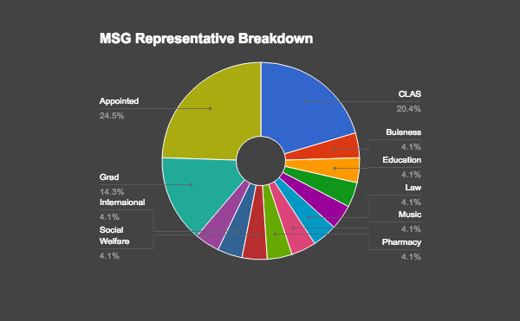

- The Multicultural Student Government shall consist of:
- Multicultural Student Government President
- Multicultural Student Government Vice President
- 10 undergraduate representatives from the College of Liberal Arts and Sciences
- 2 representatives each of the 5 divisions of CLAS
- 2 undergraduate representatives from the School of Business
- 2 undergraduate representatives from the School of Education
- 2 undergraduate representatives from the School of Engineering
- 2 undergraduate representatives from the School of Journalism
- 2 undergraduate representatives from the School of Law
- 2 undergraduate representatives from the School of Music
- 2 undergraduate representatives from the School of Pharmacy
- 2 undergraduate representatives from the School of Social Welfare
- 3 international representatives
- 2 non-traditional representatives
- Representatives from Multicultural groups:
  - 1 representative from Asian American Student Union (AASU)
  - 1 representative from Able Hawks
  - 1 representative from Black Student Union (BSU)
  - 1 representative from First Nations Student Association (FNSA)
  - 1 representative from Hispanic American Leadership Organization (HALO)
  - 1 representative from Hillel
  - 1 representative from International Student Association (ISA)
  - 1 representative from Multicultural Greek Council (MGC)
  - 1 representative from Muslim Student Association (MSA)
  - 1 representative from National Panhellenic (NPHC)
  - 1 representative from Reserve Officer Training Corps (ROTC) 12. 1 representative from Spectrum

- Any multicultural group is welcome to have a representative seat

Elections

The Election Code governs all Multicultural Student Government Elections.

Campaign Season
Campaign Season will be held during the 2 months prior to election day.

Tickets
“Tickets” are not allowed in Multicultural Student Government Elections. Multiple candidates are not allowed to
appear on a ballot as a team/unit

Slates
Candidates are not allowed to campaign as a “slate”. Multiple candidates are not allowed to run as a collective
team/unit

Candidates are allowed to table together, but CANNOT co-sponsor events or actively campaign as a ticket or slate.

Executive Staff Appointments
Executive Staff Candidates will be appointed/hired by members of executive staff ONLY if the position is not filled during the general election.
Election Process
Senator Election winners are determined by a scoring system established in 3 parts:
- Popular vote 40%
- Interview 30%
- Speech 30%

Executive Staff Election Winners are determined by a scoring system established in 4 parts:
- Popular Vote 30%
- Interview 30%
- Speech 30%
- Community presentation 10%

Eligibility-Multicultural Student Government Senators:
- Candidates must be an enrolled student at the University of Kansas in at least 6 hours
- Candidates must attend the Multicultural Student Government Justice in Politics Workshop
- Candidates Must have attended One (1) Social Justice Workshops/Educational Seminars PRIOR TO the election season of their candidacy
- Candidates must complete a Multicultural Student Government Elections Packet

Eligibility Multicultural Student Government Executive Board
- Candidates must be an enrolled student at the University of Kansas n at least 6 hours
- Candidates must attend the Multicultural Student Government Justice in Politics Workshop
- Candidates Must have attended Three (3) Social Justice Workshops/Educational Seminars PRIOR TO the election season of their candidacy
- Candidates must complete a Multicultural Student Government Elections Packet

Budget
39,861 year-long budget
11,706.11 allocated to student groups

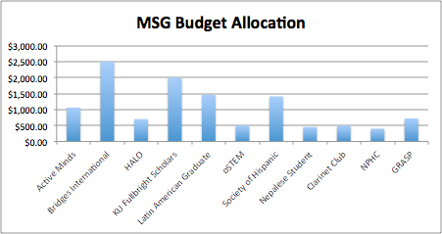

The University Senate Ad Hoc Committee on the Multicultural Student Government

The purpose for this committee will be to explore the feasibility of a Multicultural Student​
Government, and if deemed appropriate, propose amendments to the University Senate​ Code to include the Multicultural Student Government within the University Senate Code at the University of Kansas. The committee shall be comprised of the following. The student appointments shall come from the current Multicultural Student Government Board. The committee shall report to University Senate with proposed amendments to the University Senate Code by February 09, 2017.​

Chair:
Faculty :
Faculty :
Faculty:
Staff : Staff:
Staff :
Student: Trinity Carpenter
Student: Alex Kinkead
Student: Mercedes Bounthapanya

University Ad-Hoc Committee
Background & Context
While recent events have prompted the need for an ad hoc committee to direct its attention on student representation, reform to the structure is long overdue
- Recent events and individuals aside, the essential aim of this committee should be to identify edits to Rules and Regulation that have immediate, measurable outcomes.
- The current system breaks two fundamental criteria that satisfy any notion of an inclusive, representative process and governing body: Representation itself and participation in decision-making
- Senate elections have shown an alarming tendency to break these two criteria and this is largely due to the disproportionately large influence of greek, white students.
  - Participation in decision-making that affects the entire student body should not be decided by a small, non-representative group of students
  - Student senate shouldn’t purport to allow for the flourishment of broad and inclusive participation and it often does
- Focus of the Ad-Hoc Committee
  - Disseminating the concentration of power would aid equitable representation of Student Senate. From there, the aim is to see if this can be achieved by March 28
  - Making improvements to the current Student Senate is the goal. Effective, incremental and immediate changes would achieve this.
- The primary concern of this committee should be to find the most direct and meaningful way to break down such institutional barriers and concentrations of power within our time constraints. Options include:
  - Complete removal of the coalition process by referendum to the Student Body
  - Change how the Student Body President and the Student Body Vice President are elected to increase election based on merit and not solely on popularity
    - Student body speech
    - Interview component
  - Examine and make changes to the way the Student Body President and Student Body Vice President make university committee and board appointments to ensure representation by all campus groups
  - Equitable Representation in Campus Fee Review
  - Require senatorial candidates to participate in campus debates and forums with their respective divisions
  - Change the Freshmen Elections Process
  - Examine Student Senate voting and speaking rights procedure and access the feasibility of speaking rights for all students
  - Examine the Campus Fee Review allocation process and determine if there should be a window for open feedback from the Student Body (University Senate often sends amendments to full list serv, should Student Senate do this as well?)
  - Assess how freshmen students are introduced into Students and determine further ways freshmen, particularly minority freshmen, can be introduced to student senate in ways similar to white peers

DAILY KANSAS ARTICLE REPORT, 25 April 2017: Students pleased with Senate’s steps for multicultural students, looking forward to more
- Hailey Dixon | @_hailey_dixon
- Apr 25, 2017
- (…)
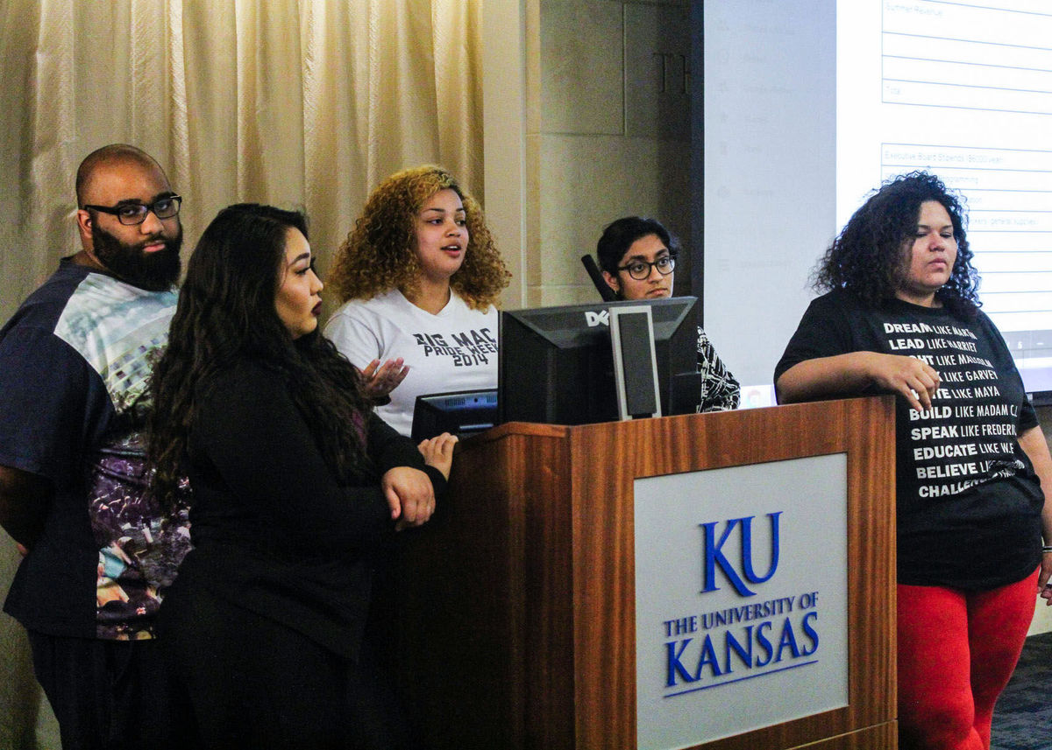
Trinity Carpenter, social welfare senator, speaks at the Finance Committee meeting about the fee bill with a group who were working to pass the bill. Miranda Clark-Ulrich, Kansan.

Top of Form
Bottom of Form
With recent initiatives established toward better multicultural representation and awareness, and funding given to Multicultural Student Government, students, like MSG chair Trinity Carpenter, are pleased with the funding for marginalized students and those of multicultural background.
Although the funding of MSG is helpful, they were originally wanting a separate government, and more funding to help students of marginalized identities and of multicultural backgrounds. MSG wanted to be established as a governing body that was equal to Student Senate in power and responsibilities.
However, the final plan ended up being a compromise between Student Senate and MSG. MSG’s original request of $2 per student, which was approved last year but vetoed by Chancellor Bernadette Gray-Little, ended up at $1 per student.
“I definitely appreciate the funding, but it came at a huge cost,” Carpenter said. “As MSG, we basically are just making sure that everything is in order to transition leadership to incoming students, and those who are going to take over.”
In addition to the funding, a bill was passed that will require student senators to finish a cultural competency training. Other than that bill and MSG funding, there has been a referendum put forth about eliminating coalitions in Student Senate elections.
With the funding established, Carpenter said that MSG’s goals are to continue to grow and to create guidelines and structure for those leading next year.
“Now having the access and ability to funds to do programming and provide financial support to marginalized students is huge,” Carpenter said.
Senate director of Diversity and Inclusion Abdoulie Njai said this last year’s administration has worked hard on creating more inclusion of all students.
“With the creation of MSG, as a part of Student Senate, I think all that will do is just help create [representation],” Njai said. “With their initiatives and the things they have planned for the next year, I think that’ll be great.”
Njai said that he is excited for the future of MSG and what they will accomplish next year.
“I know a lot of students are really excited that we were able to come to this compromise and find a way to have MSG, and have that incorporated within Student Senate as well,” Njai said. “So, I think a lot of students are excited for that.”
Carpenter said she hopes Student Senate continues to be more accessible and create more opportunities for marginalized students.
“I would like them to come up with concrete ways to support marginalized students,” Carpenter said.
Going forward, Carpenter said that she hopes winning coalition, OneKU, tries to establish multiculturalism and more social justice.
“I feel that Mady and Mattie have a lot of work ahead of them,” Carpenter said.
— Edited by Casey Brown

DAILY KANSAN REPORT, 25 April 2017: Alcorn, Naylor reflect on past year, discuss the future of Student Senate
- Darby VanHoutan | @DarbyVanHoutan
- Apr 25, 2017
Gabby Naylor and Stephonn Alcorn reflect on their past year as leaders in the senate.

Top of Form
Bottom of Form
It’s been 370 days since Student Body President Stephonn Alcorn and Student Body Vice President Gabby Naylor took office on April 20, 2016. On Wednesday, Alcorn and Naylor will transfer power and Student Senate will be in the hands of newly elected leadership.
The Kansan sat down with Alcorn and Naylor to reflect on what the past year of their leadership means to them and, more than that, what it means for the future of Student Senate.
Editor’s Note: Responses have been edited for length and clarity.

How do you feel overall with only a few days left to be in the Student Senate offices as executives?
Alcorn: The year has definitely been very challenging and kind of rewarding at the same time. I think when we finish, we can be 100 percent certain that we did everything that we set out to do. Obviously there’s always stuff you want to go back and change, but I’m definitely happy with the outcome and kind of the position that we’re leaving Student Senate in.
Naylor: If I could put it in one word, I would definitely say “proud.” We’re also a little nostalgic about the last year and excited to see the transition.

If you could pick one, what would you say has been your biggest accomplishment?
Naylor: I’m pretty excited about the way we were able to build relationships with a lot of different offices on campus that Student Senate hadn’t traditionally worked with. Definitely they always worked with Student Affairs and SILC, but there were a lot of different people on campus that played a big part in the success of all our platforms and projects this year.
Alcorn: I would say being able to institutionalize the work and the initiatives that we did so that they live on and exist outside of Student Senate and ourselves. Historically with Student Senate, you’ll see different administrations have different goals or things that they want to get done but never do. We wanted to make sure that what we did stuck. We partnered with a lot of different University offices and entities to make sure that the things we’ve done will continue having an impact after us.

What do you feel your biggest failures are?
Naylor: I think last semester we definitely set out to work a lot of with Haskell, and I think we could have used that city liaison position a lot more. We did a lot of great work with Anna [Buhlinger] and had great conversations with Haskell but I think we all, both our group of students and executive staff as well as their student government, have a lot on our plate and a lot of big topics going on this year. I wish we could have had more conversations with them and maybe collaborated on a few different projects a little more often.
Alcorn: I think after everything we’ve done, there’s always this idea in the back of your head that, “We could have done more, we could have done more.” That’s always something that has just lingered above. Could we have done more for undocumented students to enter? Could we have done more for students who don’t want guns on campus? Just things like that. Because we’re often in a lot of different spaces, if we had more time it would be less of a challenge.

How do you both feel looking back on the coalition referendum?
Alcorn: The original bill that we wrote failed in the Student Rights Committee. Our thought process was, “This conversation is too big to just let it die right here,” especially when things were going on with the Multicultural Student Government … It was kind of a wild three days, rallying up a bunch of student senators to support the bill, rewriting the entire thing, making it very neutral and saying that we need students’ input. I think that’s why, ultimately, we were able to pass it. I think everyone could understand that it wasn’t anything that was binding; we’re just asking people for feedback.
Naylor: I feel like that meeting, when we finally had it pass through full senate, was really transformational for a lot of our senators. It gave them a moment to reflect and think, “How did I get involved in this process and how did I maybe get involved and someone else didn’t?” There was a lot of personal reflection for the senators and a lot of new conversations were being had.

Seeing as how MSG was such a largely debated issue every week, how do you feel about it now?
Alcorn: With MSG, that’s something we came into this role knowing that it would eventually be something we needed to work out and find a solution for. I think we got to a place where what was passed through Student Senate was both structural and had funding. At the end of the day, there’s still one student government. One Student Senate and working with the Multicultural Student Government as an entity within Student Senate I think will be really the best route.
Naylor: I think we found a solution that benefits all multicultural students, which is really what we set out to do from day one, whether it's through MSG or through Student Senate. I think this is one thing that we could agree on, that these programs would definitely help.

How do you feel being put under review affected your time in Student Senate?
Alcorn: It characterized us as Student Senate being put under review while we were already doing the work, which is fine. The work with MSG and the coalition referendum and the cultural competency trainings and different things to make Student Senate open and accessible, that come out of the review and that committee. What happened was as we were discussing these things was think, “We don’t need to wait. We don’t need a committee report to tell us things that we can figure out now amongst ourselves.” If anything, it helped bring everyone to the table. We had the toughest conversations, but accomplished those things a whole lot sooner because we know we couldn’t just keep kicking it down the curb.
Naylor: It opened the door for a lot of conversations on the University Senate side … For the first time in the course of my year in University Senate, we were talking about how faculty and staff can help Student Senate and how we can kind of work on different projects. We were asking each other for advice and guidance and kind of understanding how each of our bodies work similarly and differently.

What do you feel is next for Student Senate?
Alcorn: What I’d love to see is that the relationships we were able to build and help elevate Student Senate across the University continue and that the next Student Senate will take those relationships and utilize them and upkeep them. Places like admissions, athletics and different places like that, taking those and making sure Student Senate is always at the forefront of conversations representing students.
Naylor: I think Student Senate can be, like Stephonn said, at the forefront of those conversations and be the moving force of what makes it so great to be at KU.
— Edited by Ashley Hocking

DAILY KANSAN, May 1: Now funded, Multicultural Student Government makes plans for the future
- Darby VanHoutan | @darbyvanhoutan
- May 1, 2017
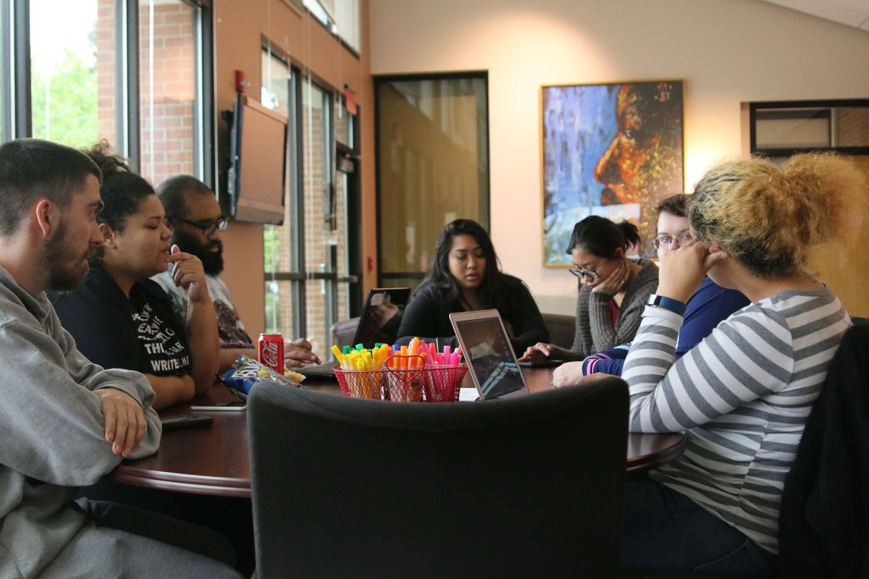

Members of the Multicultural Student Government meet on April 27 in the Office of Multicultural Affairs. Andrew Rosenthal/KANSAN
After a tumultuous two years, a student government designed specifically to represent and support multicultural and marginalized students now has a funded, but unsure future.
Multicultural Student Government (MSG) President Trinity Carpenter, a senior, is both confident and weary to leave this future after a year-long battle for recognition and funding.
Funding for MSG was first proposed by Carpenter in March 2016. This $2 fee request was ultimately vetoed by Chancellor Bernadette Gray-Little in May 2016 but brought back up this March. Ultimately, MSG was given a $1 fee and written into Student Senate Rules and Regulations.
“You invest so much in something that, as you move on, you want someone else to take ownership and make it theirs,” Carpenter said. “But always remember what brought us together in the first place and what we want to accomplish.”
The successes for MSG this year didn’t come without a fight, as senior Christian Roberson, MSG secretary, noted. Originally, the group requested the same $2 fee as the year prior, a request that seemed to be moving forward until previous Student Body President Stephonn Alcorn asked for its failure to allow more discussion.
“To the naysayers, keep talking because we have in the past and still now are going to prove you wrong,” Roberson said. “Just because we’re marginalized identities doesn’t mean that we’re stupid, that we’re not smart enough to do this. Clearly, we did it.”
This growing group originally began in a living room in January 2016, according to Carpenter. It has since grown into a fully functioning student group that, along with attempting to be the voice of multicultural students on campus, provides funding to multicultural groups such as Hispanic American Leadership Organization, Black Student Union and others.
This, Carpenter said, will be a lot easier to do with the budget Student Senate, pending the Chancellor’s approval this week, is providing through student fees.
“I already see interest growing,” Carpenter said. “It’s exciting and I don’t know if it’s because of the funding but a lot of multicultural groups are taking us a lot more seriously.”
The growing interest, both Roberson and Carpenter said, will be one of the most important things for future MSG leadership to handle. Current MSG member, junior Frank Angel, will likely be one of the individuals, and possibly executives, of the group during the upcoming year.
“The continued backlash is a problem MSG is going to face in the future,” Angel said. “Even with everything that we’ve given up, everything that Trinity is giving up especially, there’s still people who don’t believe MSG should exist in any capacity whatsoever.”
Going forward, Carpenter said, MSG’s original intentions of a $2-per-student fee and independence from Student Senate will “stay important.”
As senior and MSG member Keenan Gregory said, the discussion surrounding marginalized students at a predominantly-white institution and the fight for MSG doesn’t stop at the steps forward made this year.
“Most people tend to disbelieve the stories, especially of students of color,” Gregory said. “One great thing that MSG is sort of doing to fight that resistance is to educate through outreach and participation and not giving up at it.”
— Edited by Allison Crist

DEI members Ruben Flores and Pam Fine attended Student Senate committee meetings on March 8 and Senate parliamentary debates on March 15 and April 5. In addition, they met with Student Senate officers, MSG officers, and joint negotiating sessions during the last three legislative cycles, which closed on March 1, March 15, and April 5, respectively.
The last 3 legislative cycles of the Student Senate’s 2016-2017 legislative year closed on March 1, March 15, and April 5 and coincided with the DEI’s February 16, February 23, and March 9 meetings. The Student Senate is an autonomous body with legislative rights that operates independently of the University Senate.
There was not unanimity on this point. The DEI members who represented MSG have continued to underscore the necessity of an independent MSG student government.

